Monthly Performance Report – December 2025
Kestrel Ridge Wind Farm (75.6 MW)
David Chen · 09 January 2026 · KR-OPS-RPT-2025-12

1. Summary
Kestrel Ridge generated 24.9 GWh in December 2025, 1.2 % above the P50 budget of 24.6 GWh. Time-based availability was strong at 97.5 % (contract target 97.0 %). Mean hub-height wind speed was 9.8 m/s, above the long-term monthly mean of 9.6 m/s. Compared with December 2024 (25.9 GWh), output was down 1.0 GWh.

2. Production and key figures
KPI | December 2025 | Budget / target | YTD 2025 | YTD budget
Net generation (GWh) | 24.9 | 24.6 | 206.6 | 213.6
Time-based availability | 97.5 % | 97.0 % | 97.4 % | 97.0 %
Capacity factor | 44.3 % | 43.7 % | 31.2 % | –
Mean wind speed at hub height (m/s) | 9.8 | 9.6 | – | –
Source: Kestrel Ridge SCADA, revenue meter at 132 kV point of connection. Budget = P50 (2024 post-construction yield assessment).
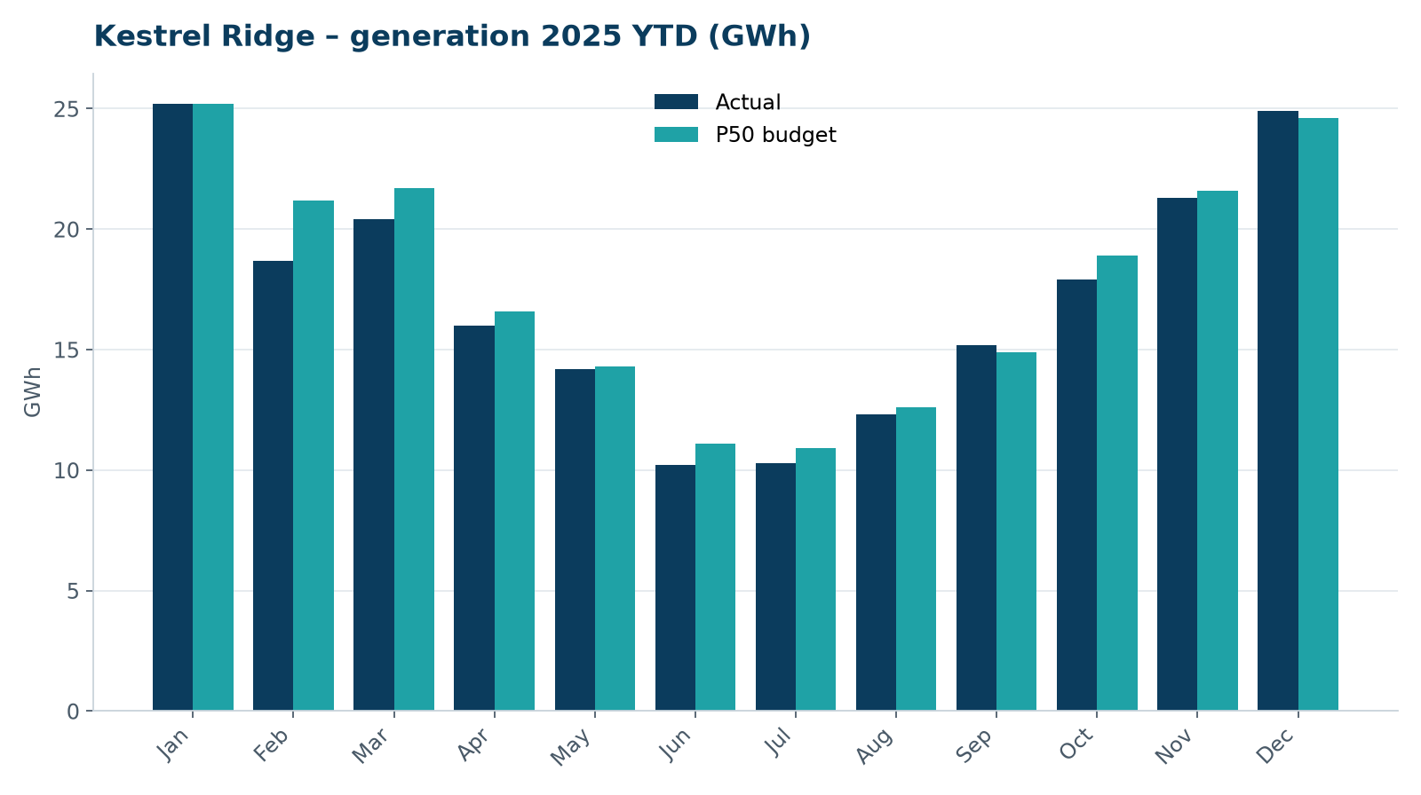
Monthly generation vs. P50 budget, 2025 year to date

3. Availability and downtime
Total turbine downtime attributable to the contractor amounted to 60 turbine-hours for the top events listed below. No grid or force majeure exclusions were claimed this month.
Turbine | Event | Downtime (h)
T-06 | nacelle cooling fan motor failure | 17
T-14 | pitch system fault – accumulator pressure low on blade A | 13
T-01 | pitch motor encoder fault on blade B | 13
T-11 | hydraulic oil leak at rotor brake caliper | 11
T-06 | service lift fault – lift locked out, turbine stopped for rescue cover | 6
Top downtime events of the month (SCADA event log, reviewed with Highline Wind Services).

4. Maintenance
- 12 corrective work orders closed, 3 still open at month end.
- Substation monthly inspection completed; no abnormalities on the 33/132 kV transformer.

5. Health, safety and environment
Indicator | Month
Hours worked on site (Highline + Weyland) | 3,101
Lost time injuries | 0
First aid cases | 0
Near misses reported | 0
Safety observations | 5
Environmental incidents | 0

No complaints from neighbours were received this month.

6. Outlook
We will review the downtime events above with Highline in the monthly O&M meeting and track the recurring pitch faults.
Prepared by Sara Lindgren (Performance Analyst); reviewed by Ben Okoye (Site Manager) and David Chen (Asset Operations Manager).

